
SPL-1 Project Report, 2019

A shooting Game

SE 305: Software Project Lab 1

Submitted by

Md. Muntakim Hye
BSSE Roll No. : 1038

Supervised by

Md. Mahabubul Alam Joardar

Institute of Information Technology

Institute of Information Technology

University of Dhaka

[29-05-2019]

Introduction
This project is about creating a simple shooting game using the C language. Although many games are built on other programming language which are superior in terms of usability, The main purpose of creating such a game is learning many functions C has to offer. Many famous games are built with C the most famous one is Quake II. This is a simple game where a player can shoot an enemy , jump and move.

Background Study

Just using C for game development is not enough.. it is very hard to make graphical interfaces when making a game. So there are certain tools that helped me make the game in C language.

1.Learning APIs: In computer programming, an application programming interface (API) is a set of subroutine definitions, communication protocols, and tools for building software. In general terms, it is a set of clearly defined methods of communication among various components. A good API makes it easier to develop a computer program by providing all the building blocks, which are then put together by the programmer.
2.Events(Game loops): Event-driven programming is a programmingparadigm in which the flow of program execution is determined by events - for example a user action such as a mouse click, key press, or a message from the operating system or another program.
3.Drawing Images:I have used SDL to draw and work with images. SDL is Simple DirectMedia Layer.It is a cross-platform development library designed to provide low level access to audio, keyboard, mouse, joystick, and graphics hardware via OpenGL and Direct3D.It can be used to make animations and video games.
4. Collision Detection: collision detection is most often associated with its use in video games and other physical simulations.
5.Dynamic memory: Dynamic Memory Allocation can be defined as a procedure in which the size of a data structure (like Array) is changed during the runtime . In this case malloc() has been used in the game.

Challenges

There were some challenges when trying to execute the program. When making the game elements simply declaring them would have posed certain problems: such as no graphics, no outputs etc.. To counter those problem, i had to go through a certain set of solutions .
For example: There were some events which had to be made one after another. Just simply making them weren’t enough to get the desired outputs.
I also had to use the SDL layer to work with the background and the player.After using the SDL i was able to make the graphics neccessary to move the player .
One of the tricky situations i got myself into is the collision detection. How will the player be able to stand on a surface and not fall?? how will the player be able to shoot and move. How will be the enemy get shot and blast. This time i had to made numarous attempts of trial and error to make those functions work.

Project Overview
This is a game developed in C language where a player can shoot , move, jump .On the other hand there is also a an enemy added which will get distroyed if he gets shot.
There are certain functionsn used in the development of the game.
1.API
2.Evens(Game loops)
3.Drawing Images
4.Drawing players and backgounds.
5.using sprites from the sheets.
6.Collision detection to move the player realisticly

User Manual

In this game the job is to make the player shoot bullets, move and jump. On the other hand the enemy will die if he gets shot .

The job is to press certain keys on the keyboard to get the desired output. In ths case the input buttons are UP : which will make the player jump.
LEFT: The player will move to the left.
RIGHT: The player will move to the right.
SPACE:Shoot

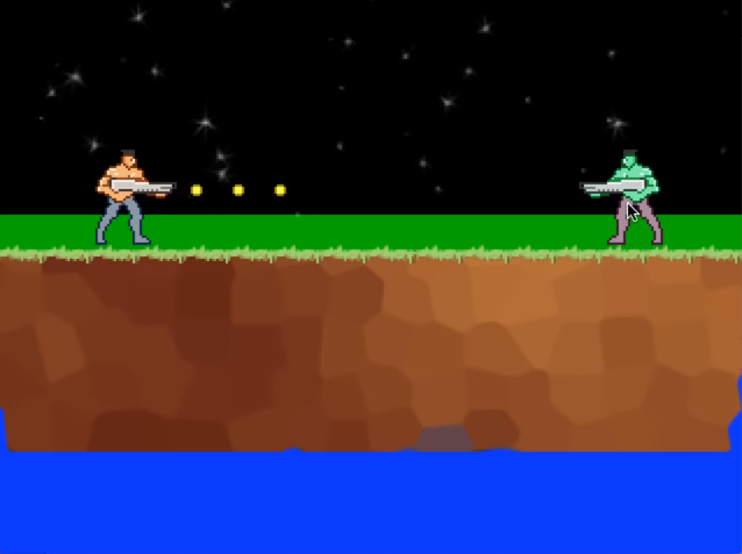

References

- https://www.geeksforgeeks.org/dynamic-memory-allocation-in-c-using-malloc-calloc-free-and-realloc/
- https://codereview.stackexchange.com/questions/123738/event-scheduler-in-c
- https://www.geeksforgeeks.org/sdl-library-in-c-c-with-examples/
- https://stackoverflow.com/questions/13868836/collision-detection-in-c

